1. Write a shell script to calculate simple interest.

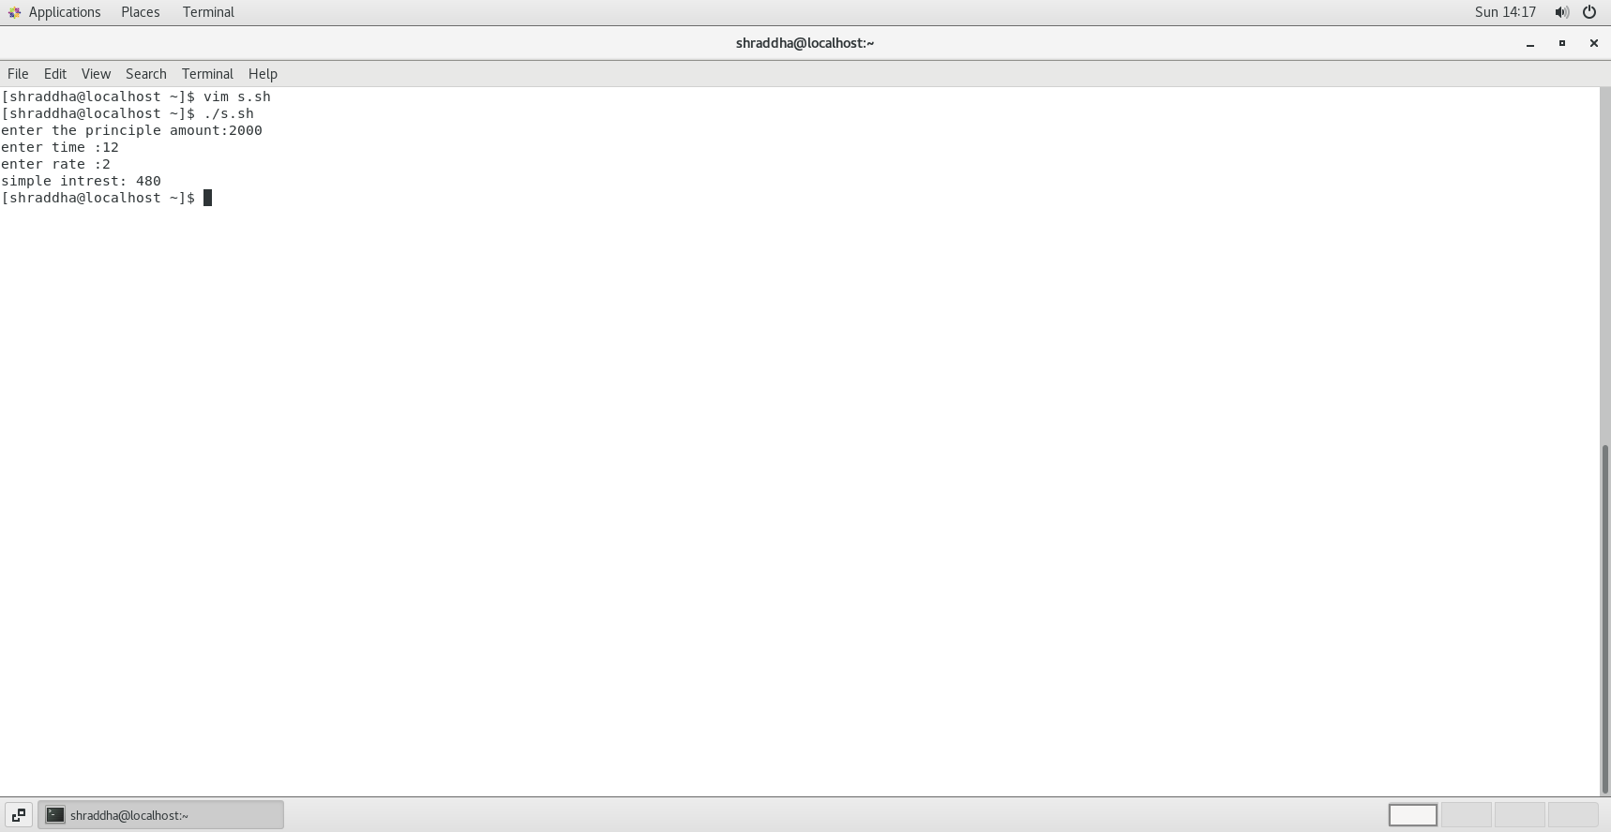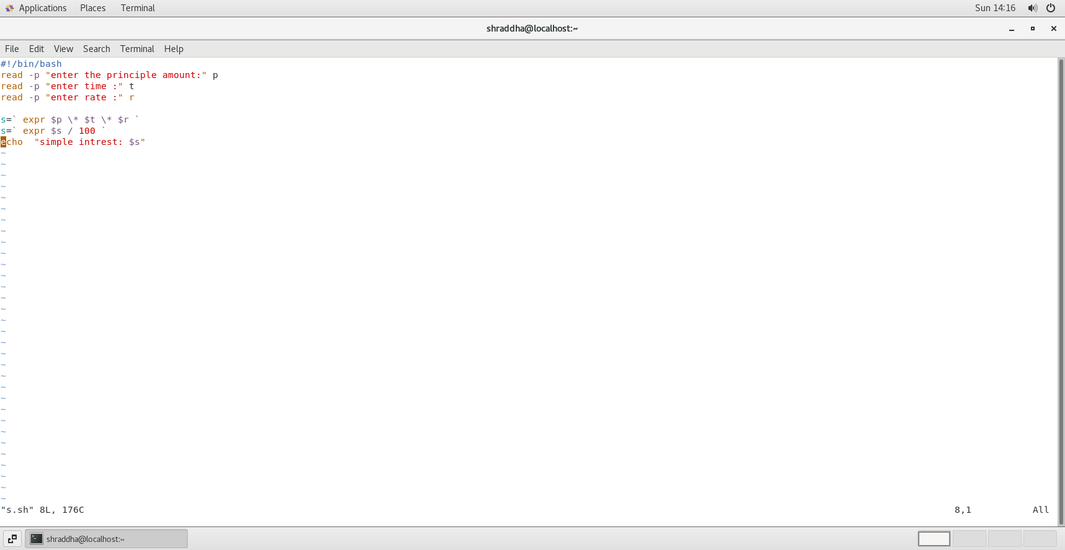

2) Write a shell script to calculate salary from given basic.

Salary = basic + dp + da +hra +ma –pf

basic – to be taken as input

dp - 50 % of basic

da - 35 % of (basic + dp)

hra - 8 % of (basic + dp)

ma - 3 % of (basic + dp)

pf - 10% of (basic + dp)

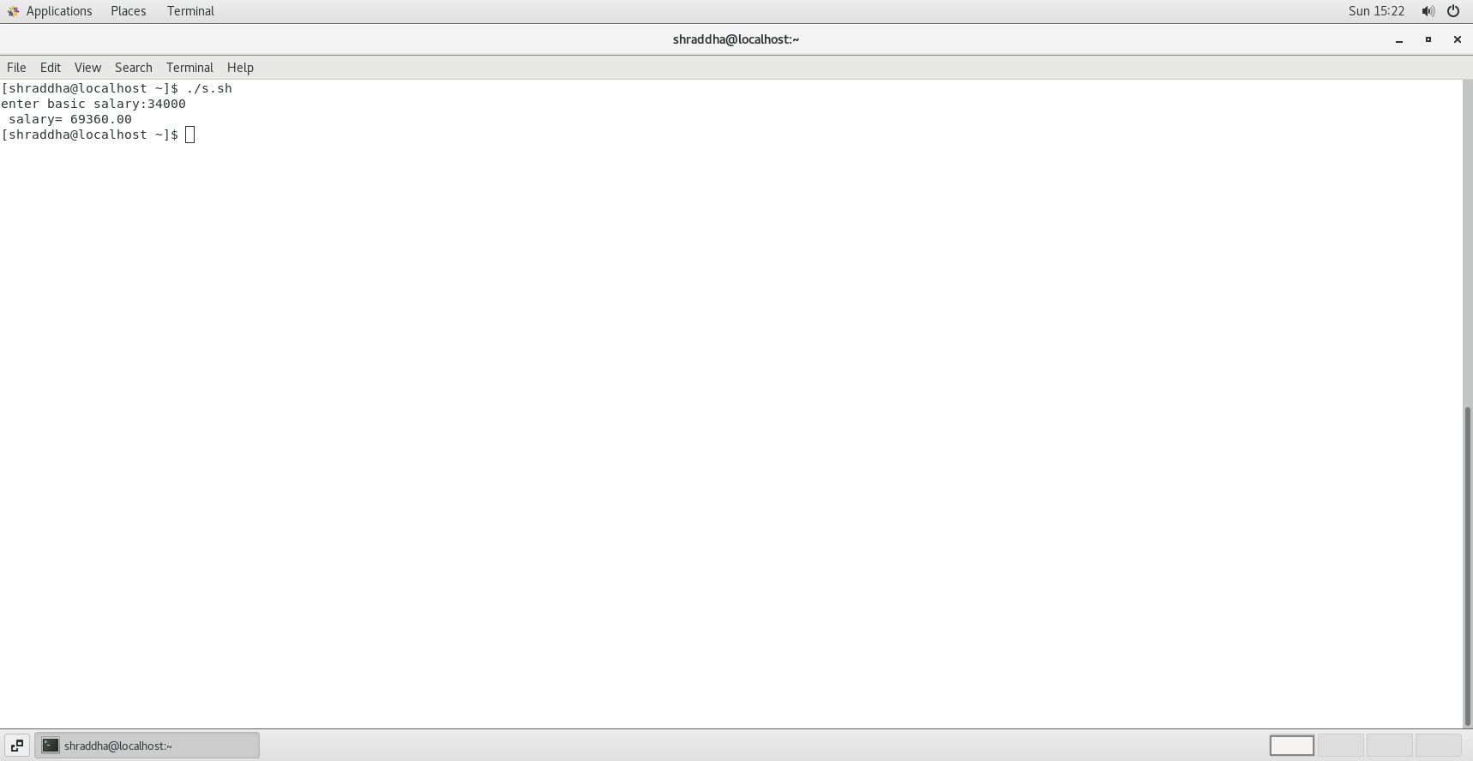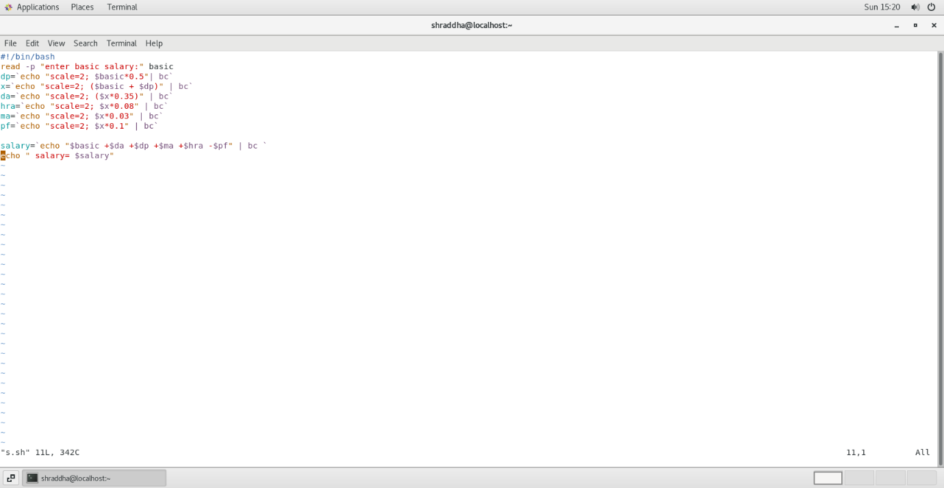

3) Write a shell script to calculate the average of a 3 number.

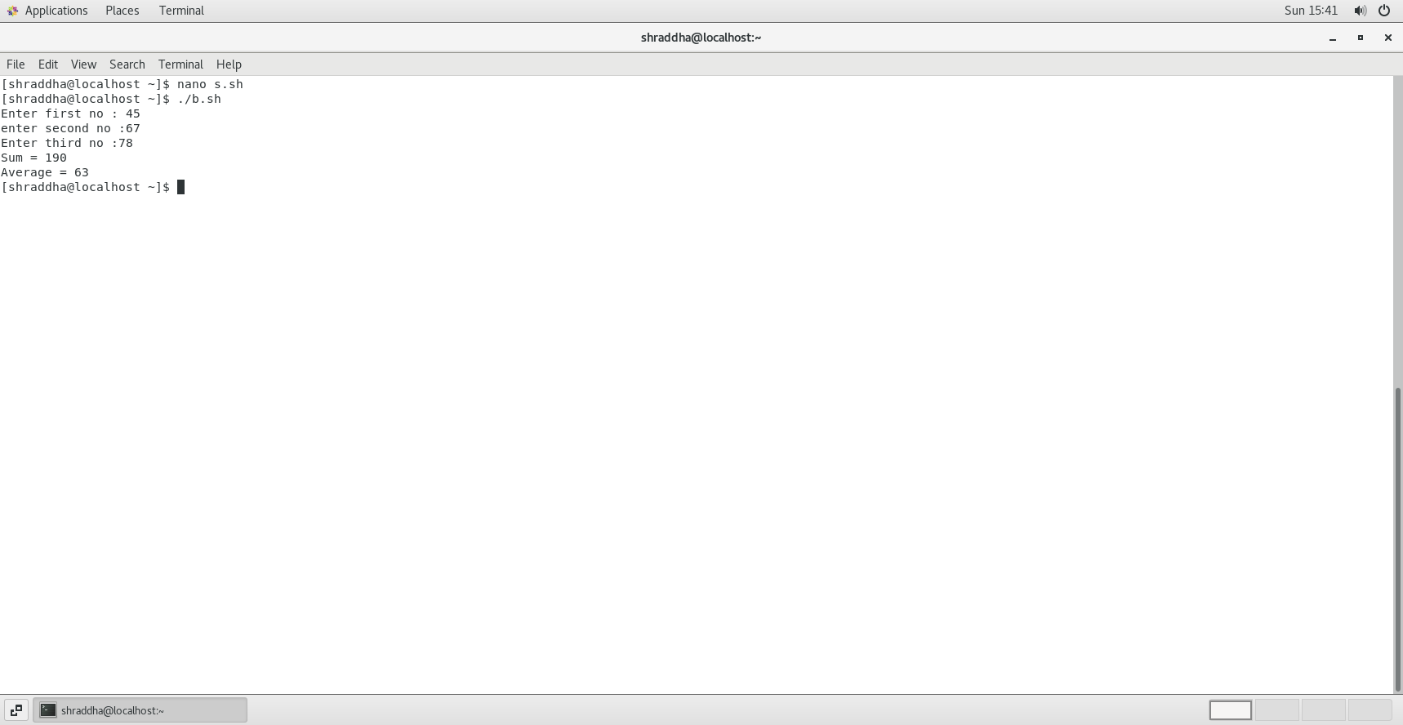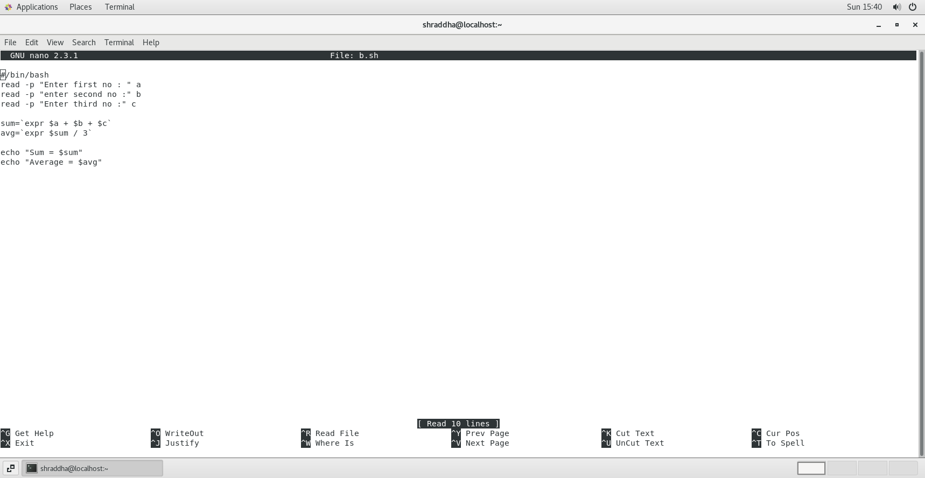

4) Write a shell script to accept 2 numbers and display which number is greater

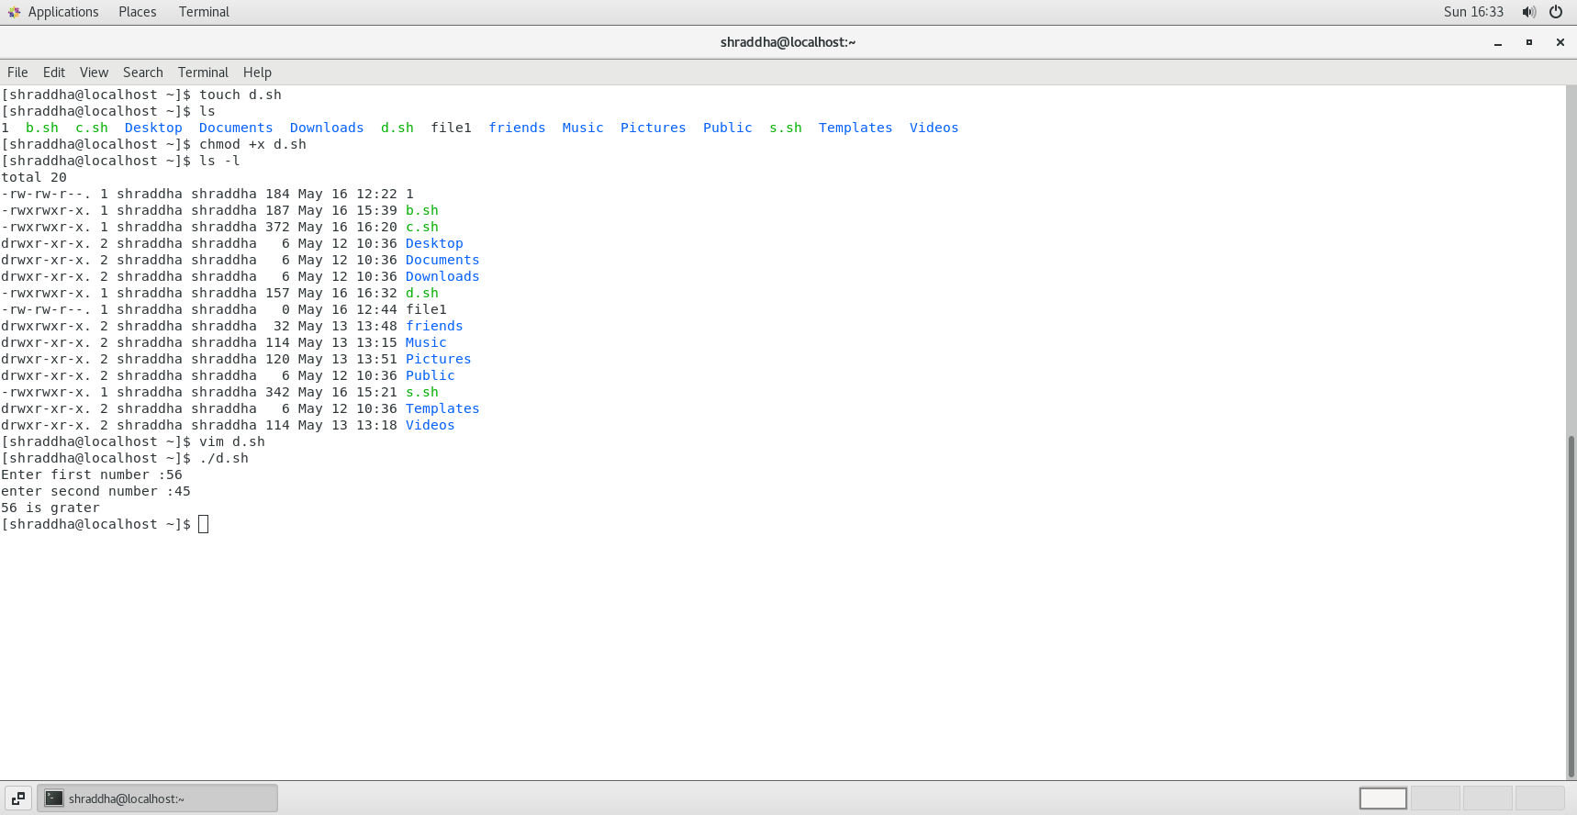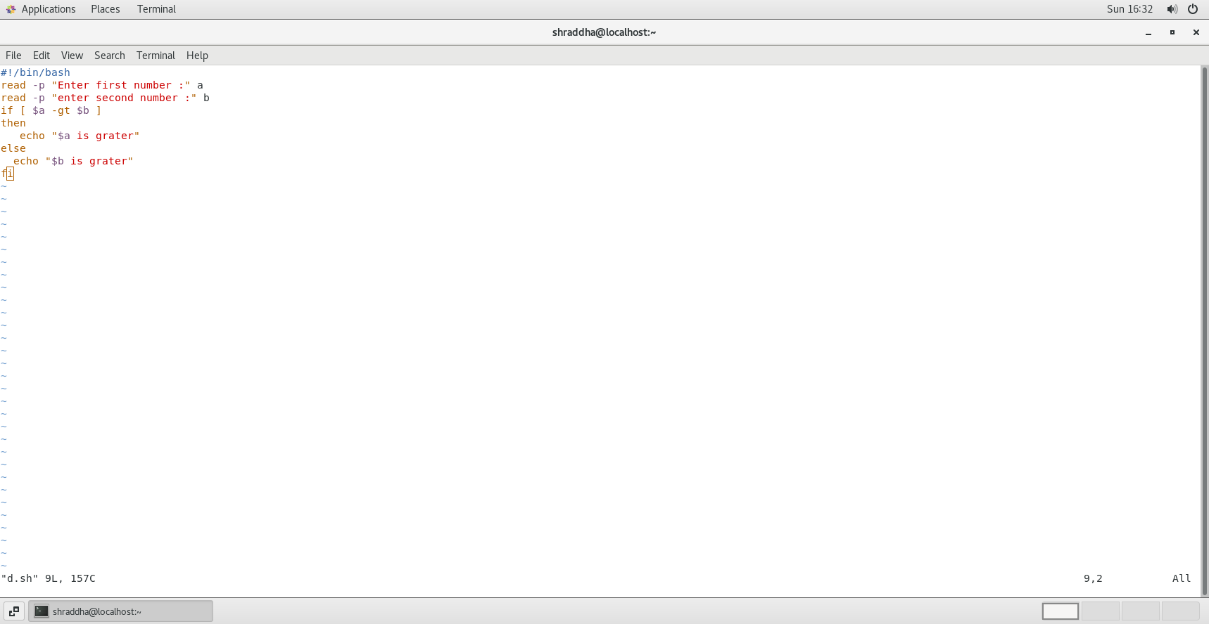

5) Create a script to

Create user , Delete user , Create group , delete Group using case

